2.CRUD

TASK.JAVA

package com.example.demo.Task;

import jakarta.persistence.Entity;

import jakarta.persistence.Id;

@Entity

public class Task {

@Id

private int id;

private String StudentName;

private String departmentName;

private String section;

private long mobile;

private String mailid;

private String address;

public Task(int id, String studentName, String departmentName, String section, long mobile, String mailid,

String address) {

super();

this.id = id;

StudentName = studentName;

this.departmentName = departmentName;

this.section = section;

this.mobile = mobile;

this.mailid = mailid;

this.address = address;

}

public Task() {

super();

// TODO Auto-generated constructor stub

}

public int getId() {

return id;

}

public void setId(int id) {

this.id = id;

}

public String getStudentName() {

return StudentName;

}

public void setStudentName(String studentName) {

StudentName = studentName;

}

public String getDepartmentName() {

return departmentName;

}

public void setDepartmentName(String departmentName) {

this.departmentName = departmentName;

}

public String getSection() {

return section;

}

public void setSection(String section) {

this.section = section;

}

public long getMobile() {

return mobile;

}

public void setMobile(long mobile) {

this.mobile = mobile;

}

public String getMailid() {

return mailid;

}

public void setMailid(String mailid) {

this.mailid = mailid;

}

public String getAddress() {

return address;

}

public void setAddress(String address) {

this.address = address;

}

}

ApiService.Java

package com.example.demo.Service;

import java.util.Optional;

import org.springframework.beans.factory.annotation.Autowired;

import org.springframework.stereotype.Service;

import com.example.demo.Task.Task;

import com.example.demo.TaskRepository.TaskRepo;

@Service

public class ApiService {

@Autowired

TaskRepo repository;

public Optional<Task> getTask(int id){

return repository.findById(id);

}

public String deleteDetails(int id) {

repository.deleteById(id);

return "id Deleted";

}

}

ApiController.Java

package com.example.demo.Controller;

import java.util.List;

import java.util.Optional;

import org.springframework.beans.factory.annotation.Autowired;

import org.springframework.web.bind.annotation.DeleteMapping;

import org.springframework.web.bind.annotation.GetMapping;

import org.springframework.web.bind.annotation.PathVariable;

import org.springframework.web.bind.annotation.PostMapping;

import org.springframework.web.bind.annotation.PutMapping;

import org.springframework.web.bind.annotation.RequestBody;

import org.springframework.web.bind.annotation.RequestParam;

import org.springframework.web.bind.annotation.RestController;

import com.example.demo.Service.ApiService;

import com.example.demo.Task.Task;

import com.example.demo.TaskRepository.TaskRepo;

@RestController

public class ApiController {

@Autowired

TaskRepo serviceRepository;

@Autowired

ApiService service;

@GetMapping("/get")

List<Task> getList(){

return serviceRepository.findAll();

}

@PostMapping("/post")

public Task create(@RequestBody Task t) {

return serviceRepository.save(t);

}

@GetMapping("/get/{id}")

public Optional<Task> getbyid(@PathVariable int id){

return service.getTask(id);

}

@DeleteMapping("/del")

public String delete(@RequestParam int id) {

return service.deleteDetails(id);

}

@PutMapping("/put")

public String update(@RequestBody Task t)

{

return service.updateDetails(t);

}

}

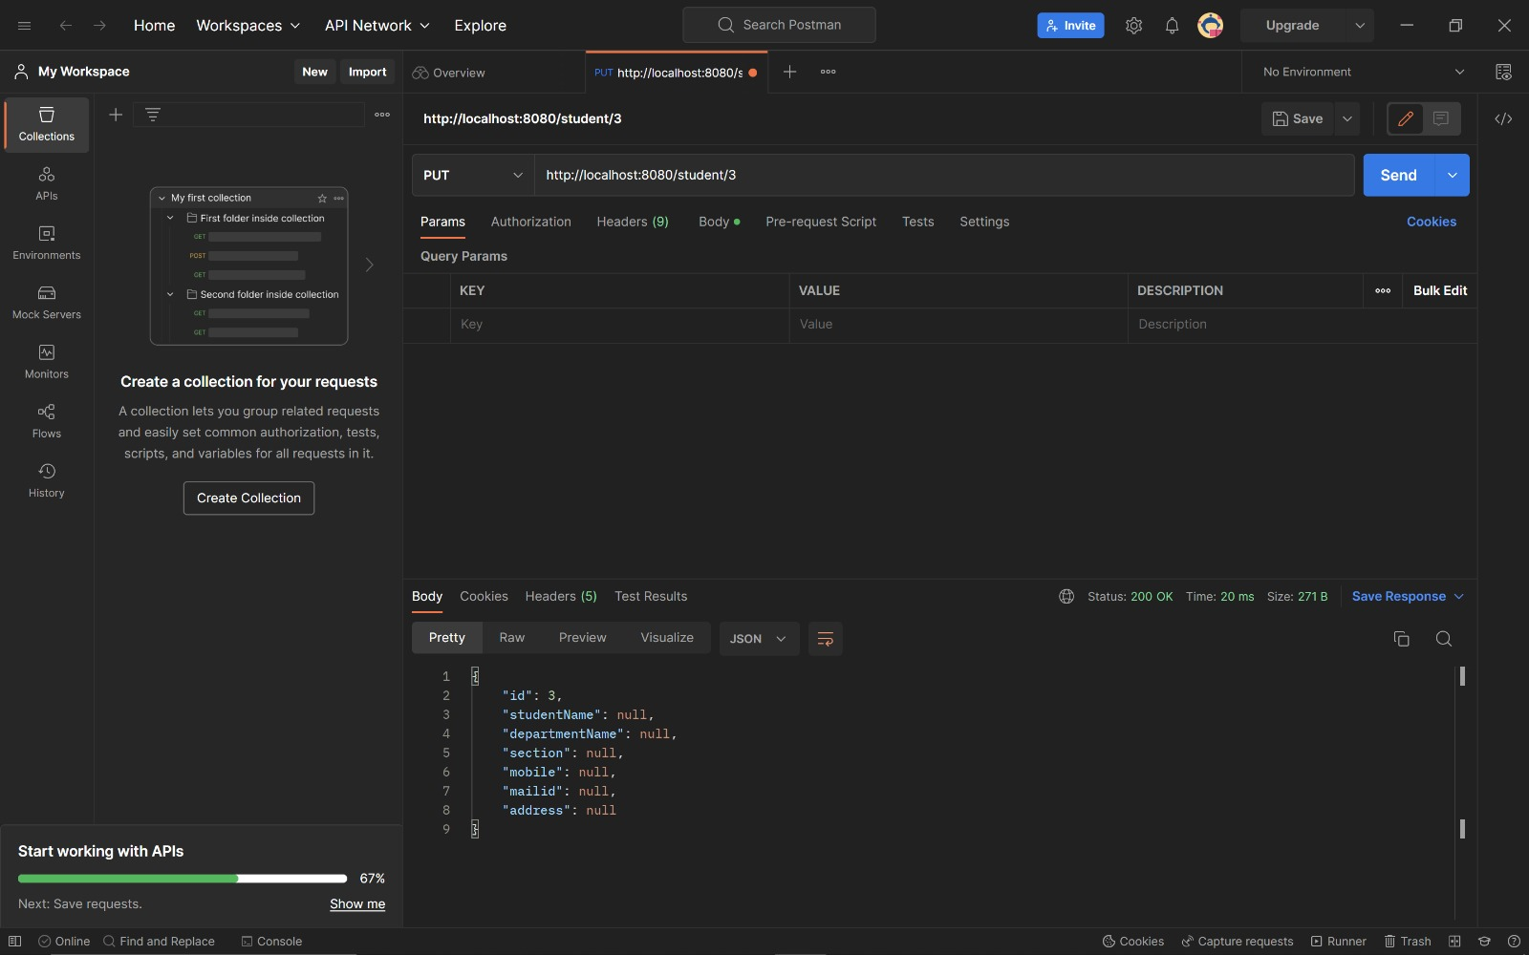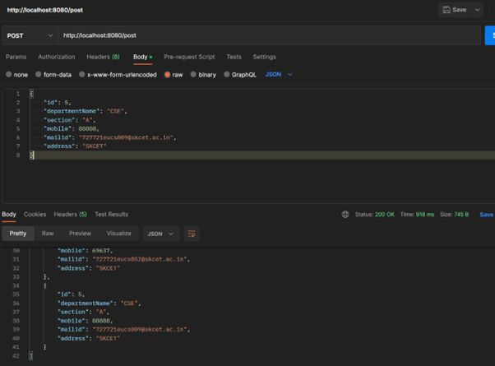

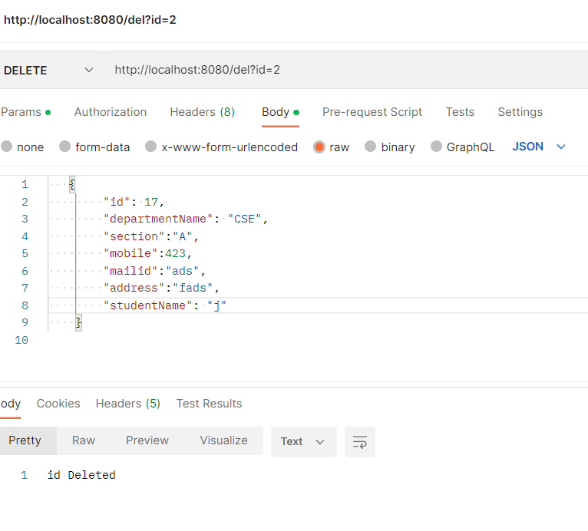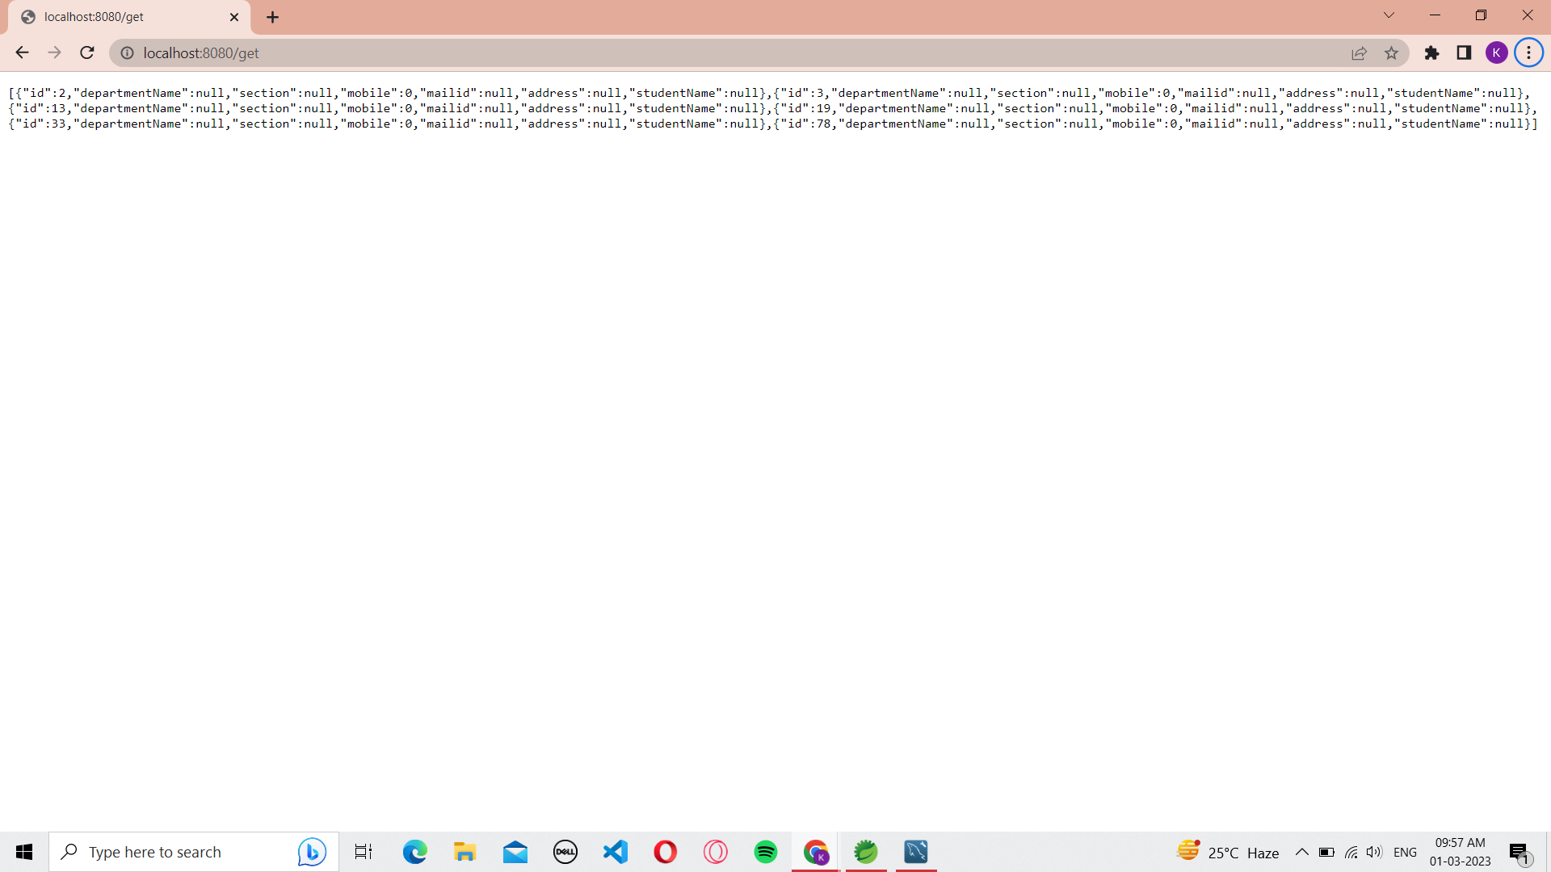

4.REST API-WELCOME

ApiController.java

package com.example.demo;

import org.springframework.web.bind.annotation.GetMapping;

import org.springframework.web.bind.annotation.RestController;

@RestController

public class ApiController

{

String name = "Kaushik";

@GetMapping("/")

public String welcome ()

{

return "Welcome "+name;

}

}

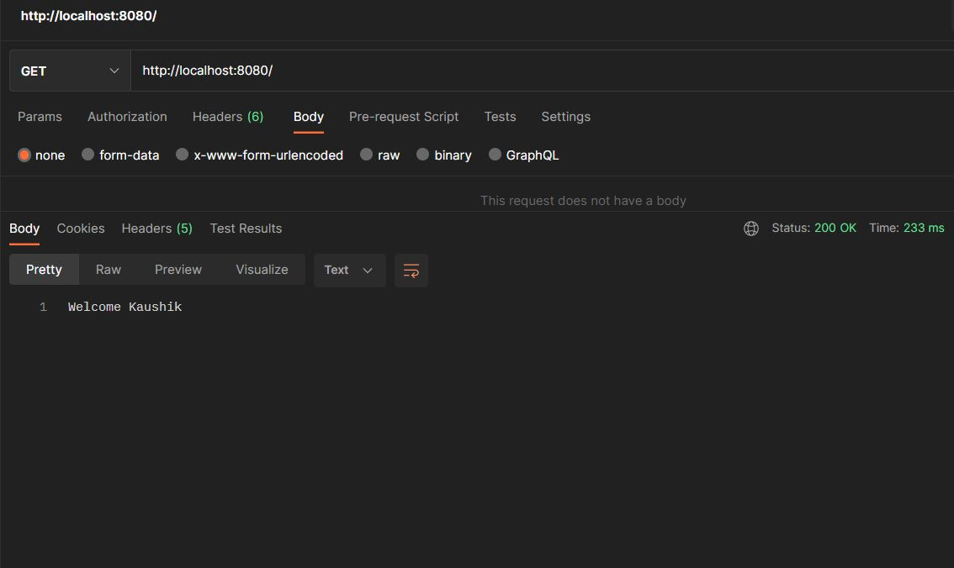

1.SPRING BOOT – ADDRESS

ApiController.java

package com.example.demo.Controllers;

import java.util.List;

import org.springframework.beans.factory.annotation.Autowired;

import org.springframework.web.bind.annotation.GetMapping;

import org.springframework.web.bind.annotation.RestController;

import com.example.demo.Models.Address;

import com.example.demo.Repository.AddressRepository;

@RestController

public class ApiController

{

@Autowired

AddressRepository addrepo;

@GetMapping("/")

List<Address> getaddress()

{

return addrepo.findAll();

}

}

Address.java

package com.example.demo.Models;

import jakarta.persistence.Entity;

import jakarta.persistence.Id;

@Entity

public class Address

{

@Id

private String employeename;

private String address;

private int pincode;

public Address() {

super();

// TODO Auto-generated constructor stub

}

Address(String employeename, String address, int pincode) {

super();

this.employeename = employeename;

this.address = address;

this.pincode = pincode;

}

public String getEmployeename() {

return employeename;

}

public void setEmployeename(String employeename) {

this.employeename = employeename;

}

public String getAddress() {

return address;

}

public void setAddress(String address) {

this.address = address;

}

public int getPincode() {

return pincode;

}

public void setPincode(int pincode) {

this.pincode = pincode;

}

}

AddressRepository.java

package com.example.demo.Repository;

import org.springframework.data.jpa.repository.JpaRepository;

import com.example.demo.Models.Address;

public interface AddressRepository extends JpaRepository<Address,String>

{

}

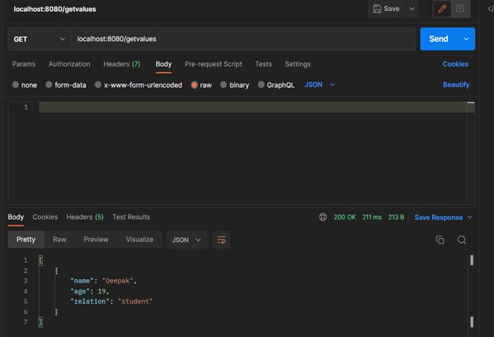

5.GET AND POST

Student.java

package com.example.demo;

public class Student {

int id;

String departmentName;

String section;

long mobile;

String mailid;

String address;

public Student(int id, String departmentName, String section, long mobile, String mailid, String address) {

super();

this.id = id;

this.departmentName = departmentName;

this.section = section;

this.mobile = mobile;

this.mailid = mailid;

this.address = address;

}

public Student() {

super();

// TODO Auto-generated constructor stub

}

public int getId() {

return id;

}

public void setId(int id) {

this.id = id;

}

public String getDepartmentName() {

return departmentName;

}

public void setDepartmentName(String departmentName) {

this.departmentName = departmentName;

}

public String getSection() {

return section;

}

public void setSection(String section) {

this.section = section;

}

public long getMobile() {

return mobile;

}

public void setMobile(long mobile) {

this.mobile = mobile;

}

public String getMailid() {

return mailid;

}

public void setMailid(String mailid) {

this.mailid = mailid;

}

public String getAddress() {

return address;

}

public void setAddress(String address) {

this.address = address;

}

}

Controller.java

package com.example.demo;

import java.util.\*;

import org.springframework.web.bind.annotation.GetMapping;

import org.springframework.web.bind.annotation.PostMapping;

import org.springframework.web.bind.annotation.RequestBody;

import org.springframework.web.bind.annotation.RestController;

@RestController

public class StudentController {

@GetMapping("/home")

public String homepage()

{

return("Welcome to student list");

}

@GetMapping("/list")

public List<Student> getList(){

List<Student> detailsList = new ArrayList<>();

detailsList.add(new Student(1,"CSE","A",93602,"727721eucs034@skcet.ac.in","SKCET"));

detailsList.add(new Student(2,"CSE","A",81234,"727721eucs015@skcet.ac.in","SKCET"));

detailsList.add(new Student(3,"CSE","A",97526,"727721eucs033@skcet.ac.in","SKCET"));

detailsList.add(new Student(4,"CSE","A",69637,"727721eucs052@skcet.ac.in","SKCET"));

return detailsList;

}

@PostMapping("/post")

public List<Student> addStudent(@RequestBody Student newStudent) {

List<Student> detailsList = new ArrayList<>();

detailsList.add(new Student(1,"CSE","A",93602,"727721eucs034@skcet.ac.in","SKCET"));

detailsList.add(new Student(2,"CSE","A",81234,"727721eucs015@skcet.ac.in","SKCET"));

detailsList.add(new Student(3,"CSE","A",97526,"727721eucs033@skcet.ac.in","SKCET"));

detailsList.add(new Student(4,"CSE","A",69637,"727721eucs052@skcet.ac.in","SKCET"));

detailsList.add(newStudent);

return detailsList;

}

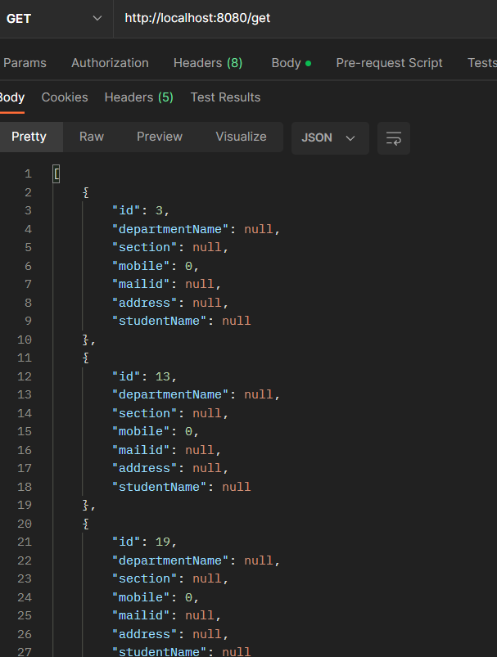

3.FAMILY

Model.java

package com.example.springapp.Controllers;

import java.util.ArrayList;

import com.example.springapp.Models.Family;

import org.springframework.web.bind.annotation.GetMapping;

import org.springframework.web.bind.annotation.RequestMapping;

import org.springframework.web.bind.annotation.RestController;

@RestController

@RequestMapping("/family")

public class ApiController {

@GetMapping("/getFamilyDetails")

public ArrayList<Family> getFamilyDetails() {

ArrayList<Family> familyList = new ArrayList<>();

familyList.add(new Family("John Doe", 30, "Brother"));

familyList.add(new Family("Jane Doe", 25, "Sister"));

familyList.add(new Family("Mary Smith", 60, "Mother"));

return familyList;

}

}

Controller.java

package com.example.springapp.Models;

public class Family {

private String name;

private int age;

private String relation;

// Constructors

public Family() {}

public Family(String name, int age, String relation) {

this.name = name;

this.age = age;

this.relation = relation;

}

// Getters and setters

}

